

**INTERNATIONAL SCHOOL**

**CAPSTONE PROJECT 1**

**CMU-CS 246 HIS**

**PROJECT PLAN DOCUMENT**

Version: 1.1

**CALCULATOR SOFTWARE - CS**

**Mentor: Nguyen Dang Quang Huy**

***Team Member*:**

Lê Quang Anh

Trương Xuân Bảo

Phạm Quỳnh Chi

Bùi Tạ Hồng Đạt

Liễu Thị Thuỳ Trang

**Approved by Huy Nguyen Dang Quang**

**Project Plan Review Panel Representative:**

Name Signature Date

**Capstone Project 1- Mentor:**

Name Signature Date

Da Nang, 01/2024

**PROJECT INFORMATION**

| **Project Acronym** | CS |
| --- | --- |
| **Project Title** | Calculator Software | | | |
| **Start Date** | 25 – Jan –2024 | **End Date** | 19 – Fer –2024 | |
| **Lead Institution** | International School, Duy Tan University | | | |
| **Team Member** | **Name** | **Email** | | **Phone** |
| 28211100194 | Lê Quang Anh | lequanganhh1624@gmail.com | | 0329163990 |
| 28211133323 | Trương Xuân Bảo | [truongxuanbao2004@gmail.com](mailto:truongxuanbao2004@gmail.com) | | 0889606440 |
| 28209020840 | Phạm Quỳnh Chi | [quynhchihtk84@gmail.com](mailto:quynhchihtk84@gmail.com) | | 0835650230 |
| 28219002511 | Bùi Tạ Hồng Đạt | Datroobin@gmail.com | | 0795580904 |
| 28209024783 | LiễuThị Thuỳ Trang | [tt1605589@gmail.com](mailto:tt1605589@gmail.com) | | 0353093304 |

**PROJECT PLAN DOCUMENT**

| **Document Title** | Project Plan Document | | |
| --- | --- | --- | --- |
| **Author(s)** | 246 HIS Team 1 | | |
| **Date** | Jan 26th, 2024 | **File name:** | C1SE.28_CS_ProjectPlan_v1.1.docx |
| **URL** | https://drive.google.com/drive/u/0/folders/1divRQwKtEeAWXxM2Dx5fuFPS8FIYdeZW | | |
| **Access** | Project and CMU Program | | |

**SIGNATURE**

**Document Approvals:** The following signatures are required for approval of this document.

| **Mentor** | Huy, Nguyen Dang Quang | **Signature:** |  |
| --- | --- | --- | --- |
| **Date:** |  |
| **Project Manage** | Quynh Chi Pham | **Signature:** |  |
| **Date:** |  |
| **ProDuct**  **Owner** | Huy Nguyen Dang Quang | **Signature:** |  |
| **Date:** |  |
| **Team member(s)** | Quang Anh, Xuan Bao | **Signature:** |  |
| **Date:** |  |
| Hong Dat, Thuy Trang | **Signature:** |  |
| **Date:** |  |

**REVISION HISTORY**

| **Version** | **Person(s)** | **Date** | **Description** |
| --- | --- | --- | --- |
| **1.0** | All members | Jan 25th, 2024 | Draft |
| **1.1** |  |  | Final |

**TABLE OF CONTENTS**

**1. PROJECT DESCRIPTION 5**

**2.1.1. REASON FOR SELECTING 6**

**2..1.2 WATERFALL METHODOLOGY 6**

**3. DETAILED SCHEDULE 7**

# 1. PROJECT DESCRIPTION

| **Project code** | CS | **Contract type** | Internal Project |
| --- | --- | --- | --- |
| **Customer** | N/A | **End-user** | Customer/User |
| **Project type** | Internal | **Project Manager/**  **Project Leader** | Quynh Chi Pham |
| **Project category** | Calculator Software | **Business Domain** | AI |
| **Application type** | Web Application |  |  |

***Table 1:*** *Project Description*

Calculator app is a useful tool that helps you perform basic and advanced math calculations quickly and accurately. This software is often used in fields such as studying, research, accounting, finance, etc., or calculating something in your life.

With a friendly user interface, users can easily enter data perform basic math operations, and produce the fastest results. In addition, it can also support additional features such as unit conversion, solving equations, and performing complex mathematical functions if you want. With powerful and flexible computing capabilities, this application is not only a useful tool in daily life but also a powerful assistant for professionals and working users. jobs in other fields. At the same time, its flexibility and ease of use help people save time and energy when performing daily calculations.

**2. PROJECT DEVELOPMENT APPROACH**

**2.1. TECHNICAL PROCESS**

We use waterfall development in our project. Software tools are shifting from agile applications like Trello, Slack, Google Drive, Discord to waterfall project management tools and processes and source code management tools like git. And for project requirements, we use React Native/Java for app development.

## 2.1.1. REASON FOR SELECTING

To cope with the dynamic changes in today's fast-paced technology landscape, we aim for a project development model that is highly adaptable and straightforward, aligning with the principles of the Waterfall methodology. Our project envisions continuous development of new features in the future, and we commit to regularly updating and incorporating emerging technologies to enhance the allure and intelligence of our system.

In the Waterfall project model, all features are typically developed sequentially, providing a structured and linear approach. This approach, which doesn't attempt to develop all features at once, aligns well with our team's limited experience in project development. We acknowledge that our small team may encounter challenges during the software development stages, and requirements may need to be adjusted for suitability.

In contrast to the Agile Scrum model, which involves breaking down the project into smaller, manageable tasks assigned to sprints, the Waterfall model provides a systematic and phased approach. This approach allows us to move through each phase of development, including planning, design, implementation, testing, and maintenance, in a structured manner.

Our team, being relatively small and less experienced, appreciates the clarity and predictability offered by the Waterfall model. It provides a clear roadmap for development stages, allowing for precise planning and execution. Unlike the Agile Scrum model, which is more iterative and collaborative, the Waterfall model suits our team's preference for a structured and methodical development process. We believe that applying the Waterfall model will help us address challenges effectively and achieve optimal performance in our project development

.

## 2..1.2 WATERFALL METHODOLOGY

• The Waterfall methodology was initially devised for the software industry.

• The objective was to streamline and enhance the development process by following a sequential, linear approach to identify and rectify issues and defects.

• This methodology involves progressing through distinct phases, such as planning, design, implementation, testing, and maintenance, in a structured and systematic manner.

• The Waterfall model is known for its methodical and predictable nature, addressing one phase at a time.

• In the era of digital transformation, where many organizations are transitioning to a digital workplace, the Waterfall methodology aligns well with companies seeking a structured approach to project management and overall operations **.**

2.1.3. WATERFULL PROCESS

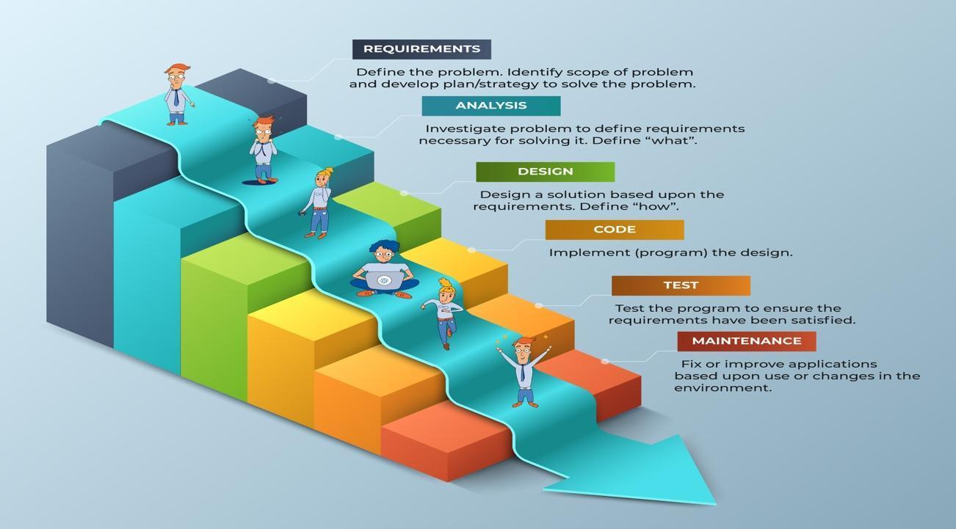

**Figure1: Project Manage**

* The project can respond easily to change.
* Problems are identified early.
* The customer gets the most beneficial work first.
* Work done will better meet the customer’s needs.
* Improved productivity.
* Ability to maintain a predictable delivery schedule.

## 3. DETAILED SCHEDULE

| **No.** | **Task Name** | **Employees** | **Start** | **Finish** | **Status** |
| --- | --- | --- | --- | --- | --- |
| **1** | **Get the request** |  |  |  |  |
| **1.1** | **Explore and identify customer needs for products under development and provide opinions** | **All teams** | **25/01/2024** | **26/01/2024** | Accomplished |
| **1.2** | **Get additional function requirements** | **Hong Dat** | **26/01/2024** | **28/01/2024** | Accomplished |
| **1.3** | **Get the subtraction function request** | **Hong Dat** | **26/01/2024** | **28/01/2024** | Accomplished |
| **1.4** | **Get the kernel function request** | **Hong Dat** | **26/01/2024** | **28/01/2024** | Accomplished |
| **1.5** | **Get the division function request** | **Hong Dat** | **26/01/2024** | **28/01/2024** | Accomplished |
| **2** | **Design** |  |  |  |  |
| **2.1** | **Design of plus function interface** | **Xuan Bao** | **29/01/2024** | **31/01/2024** | Accomplished |
| **2.2** | **Design the subtraction function interface** | **Xuan Bao** | **29/01/2024** | **31/01/2024** | Accomplished |
| **2.3** | **Design the kernel function interface** | **Xuan Bao** | **29/01/2024** | **31/01/2024** | Accomplished |
| **2.4** | **Split function interface design** | **Xuan Bao** | **29/01/2024** | **31/01/2024** | Accomplished |
| **3** | **Code** |  |  |  |  |
| **3.1** | **Code function to add 2 numbers** | **Quang Anh** | **01/02/2024** | **05/02/2024** | Accomplished |
| **3.2** | **Code function to subtract 2 numbers** | **Xuan Bao** | **01/02/2024** | **05/02/2024** | Accomplished |
| **3.3** | **Code function to multiply 2 numbers** | **Quynh Chi** | **01/02/2024** | **05/02/2024** | Accomplished |
| **3.4** | **Code function to divide 2 numbers** | **Hong Dat** | **01/02/2024** | **05/02/2024** | Accomplished |
| **3.5** | **Code f** **unction to divide percentage of 2 numbers** | **Thuy Trang** | **01/02/2024** | **05/02/2024** | Accomplished |
| **4** | **Test** |  |  |  |  |
| **4.1** | **Test the addition function and write test cases** | **Thuy Trang** | **06/02/2024** | **21/02/2024** | Accomplished |
| **4.2** | **Test the Subtract function and write test cases** | **Thuy Trang** | **06/02/2024** | **21/02/2024** | Accomplished |
| **4.3** | **Test the Kernel function and write test cases** | **Thuy Trang** | **06/02/2024** | **21/02/2024** | Accomplished |
| **4.4** | **Test the division function and write test cases** | **Thuy Trang** | **06/02/2024** | **21/02/2024** | Accomplished |
| **4.5** | **Test the percent division function and write test cases** | **Thuy Trang** | **06/02/2024** | **21/02/2024** | Accomplished |
| **4.6** | **Check the product one last time** | **Quynh Chi** | **21/02/2024** | **22/02/2024** | Accomplished |
| **5** | **Maintenance** |  |  |  |  |
| ***If you have money, you can do anything you want, let alone maintaining or upgrading it in future.*** | | | | | |
|  | | | | | |

**4. REFERENCES**

1. <https://www.researchgate.net/publication/371902449_Waterfall_Model_Used_in_Software_Development_Reference_Software_Requirements_Engineering_Waterfall_Model>
2. <https://www.techtarget.com/searchsoftwarequality/definition/waterfall-model>
3. https://www.lucidchart.com/blog/waterfall-project-management-methodology